ASSIGNMENT-2

Develop an "Automatic garage door opening system". Use an Ultrasonic sensor to detect if there is a vehicle in front of the garage. if any vehicle is detected open the garage door (rotate the servo motor) for some time and close it.

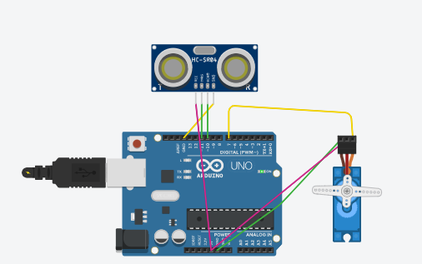

CODE ::

#include<Servo.h>

Servo myservo;

int trigpin = 11;

int echopin =10;

void setup()

{

Serial.begin(9600);

myservo.attach(7);

pinMode(trigpin,OUTPUT);

pinMode(echopin,INPUT);

myservo.write(0);

}

void loop()

{

digitalWrite(trigpin,HIGH);

delay(1000);

digitalWrite(trigpin,LOW);

float duration=pulseIn(echopin,HIGH);

float distance=duration*0.0343/2;

Serial.print("the distance is");

Serial.println(distance);

if(distance>80){

myservo.write(90);

Serial.println("the garage door is opened");

delay(5000);

myservo.write(0);

Serial.println("the garage door is closed");

}

else{

myservo.write(0);

}

}

**OUTPUT::**

the garage door is opened

the garage door is closed

the distance is139.52

the garage door is opened

the garage door is closed

the distance is140.94

the garage door is opened